

**Machine Learning**

**Homework 1**

Submitted by

**LAVEEZA AAMIR | 54064**

**Task 1:**

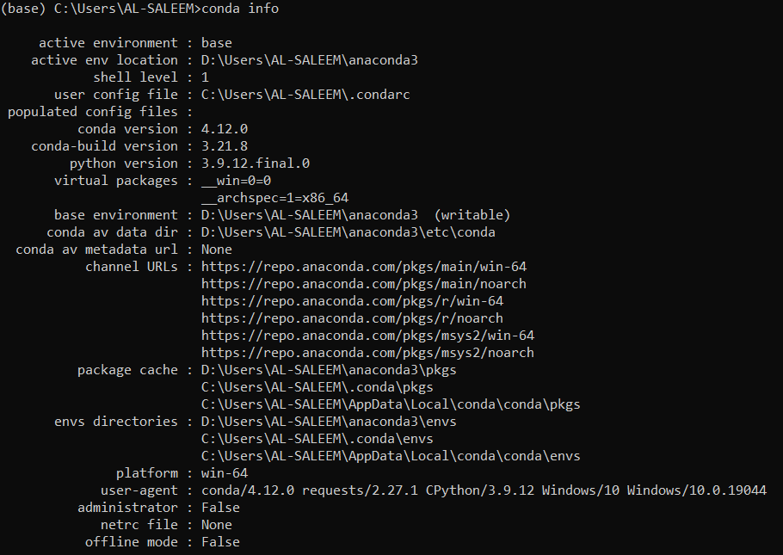

**Task 2:**

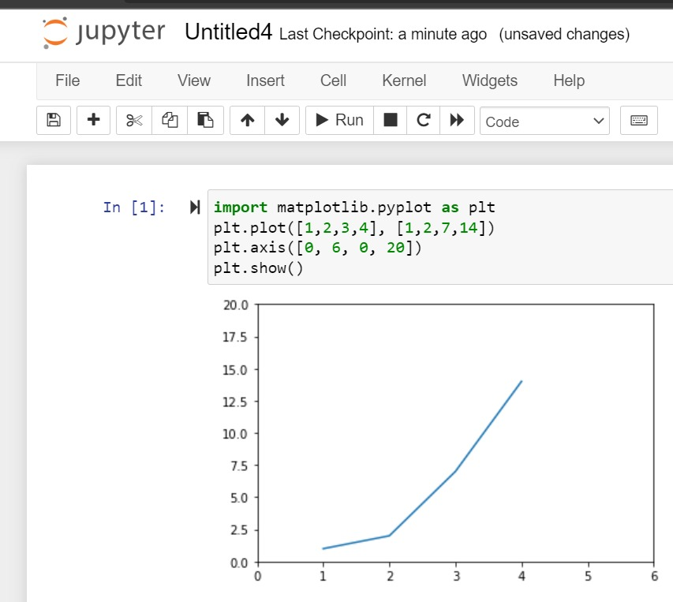

**Task 3:**

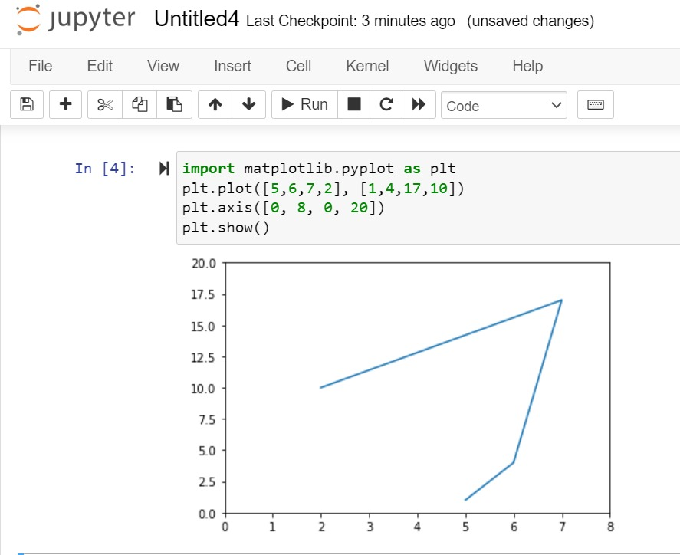

**Task 4:**

<https://github.com/Laveeza-Aamir/Machine-Learning.git>

